Apothem
# Source: AI Source: Provided by: [Data Path: Persons Table -> ID Column: 1, Name_En Column: Motasem Essam] -> From: [ChatGPT] on [7/25/2026]
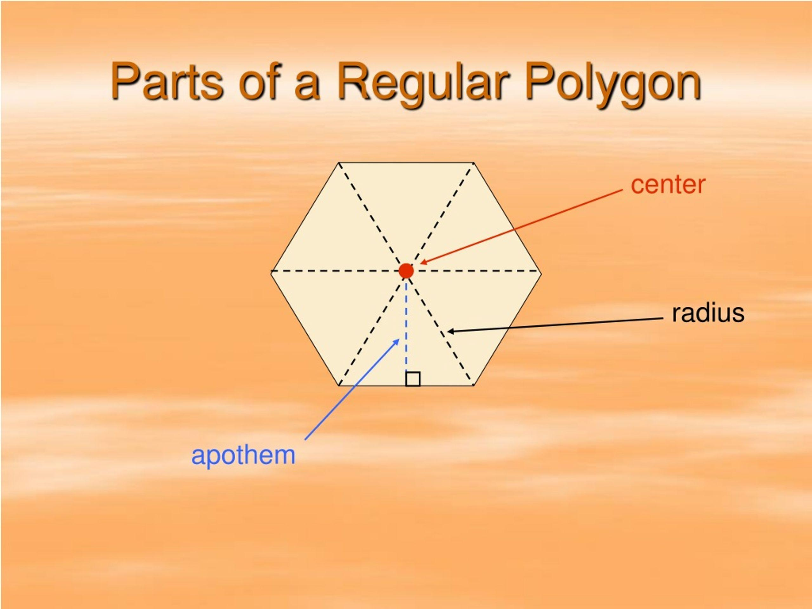
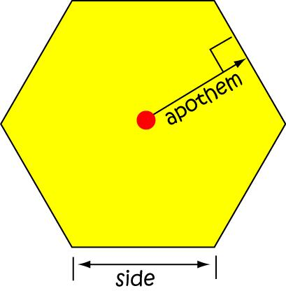
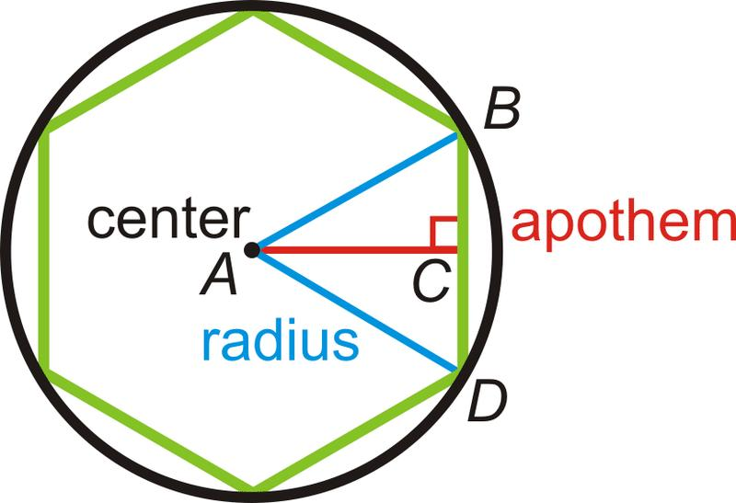
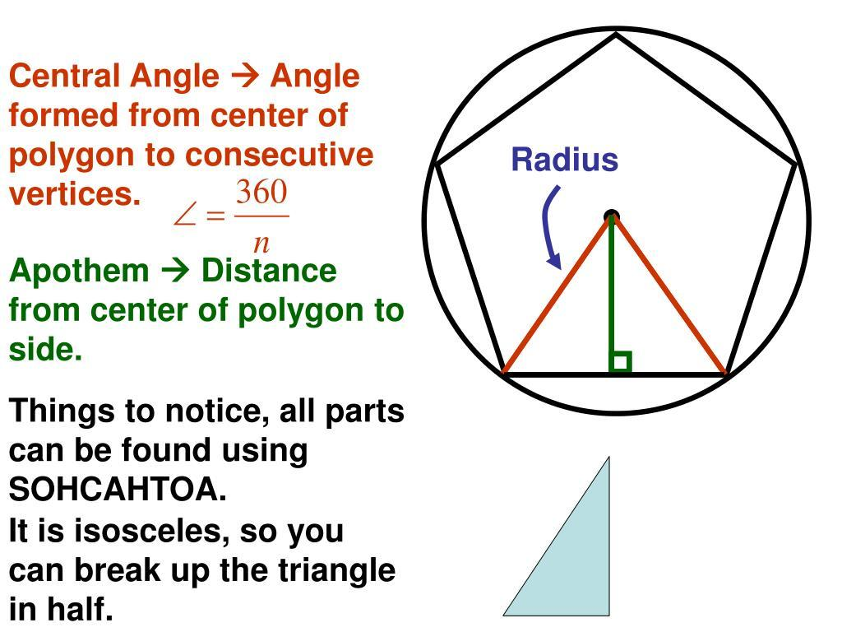
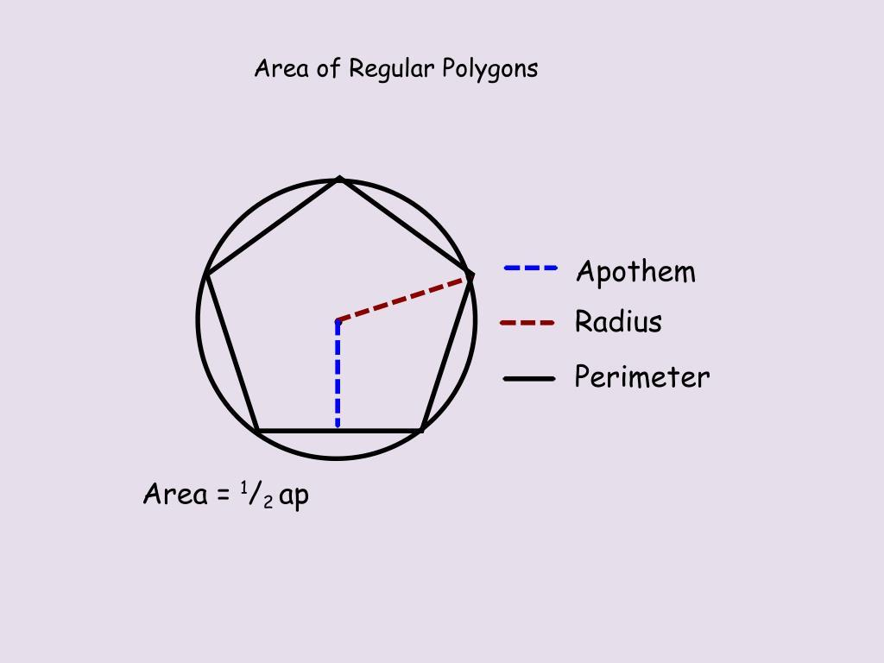

Definition
# Source: AI Source: Provided by: [Data Path: Persons Table -> ID Column: 1, Name_En Column: Motasem Essam] -> From: [ChatGPT] on [7/25/2026]
The apothem of a regular polygon is the perpendicular distance from the center of the polygon to any one of its sides.
It is usually denoted by:
$$\boxed{a}$$
If $O$is the center of a regular polygon and $M$is the midpoint of a side, then:
$$\boxed{OM=a}$$
where:
- $O$= center of the polygon
- $M$= midpoint of a side
- $OM$= apothem

Fundamental Concept
# Source: AI Source: Provided by: [Data Path: Persons Table -> ID Column: 1, Name_En Column: Motasem Essam] -> From: [ChatGPT] on [7/25/2026]
In a regular polygon, the center is equally distant from every side.
Therefore, all apothems have the same length:
$$\boxed{a_{1}=a_{2}=a_{3}=⋯=a_{n}}$$
The apothem is always perpendicular to the side to which it is drawn.
$$\boxed{OM⊥AB}$$
Because the polygon is regular, the perpendicular from the center to a side also meets that side at its midpoint.
Thus, the apothem is simultaneously:
- a perpendicular distance,
- a radius of the polygon's inscribed circle,
- a segment from the center to a side midpoint.

Main Parts
# Source: AI Source: Provided by: [Data Path: Persons Table -> ID Column: 1, Name_En Column: Motasem Essam] -> From: [ChatGPT] on [7/25/2026]
For a regular polygon with side $AB$:
- $O$= center
- $AB$= side
- $M$= midpoint of $AB$
- $OM$= apothem
- $a$= apothem length
- $R$= circumradius
- $n$= number of sides
- $s$= side length
The fundamental relationship is:
$$\boxed{OM⊥AB}$$
and:
$$\boxed{AM=MB=\frac{s}{2}}$$

Apothem and Inscribed Circle
# Source: AI Source: Provided by: [Data Path: Persons Table -> ID Column: 1, Name_En Column: Motasem Essam] -> From: [ChatGPT] on [7/25/2026]
The apothem is the radius of the inscribed circle of a regular polygon.
Therefore:
$$\boxed{a=r}$$
where $r$is the inradius.
The inscribed circle touches every side of the regular polygon at the midpoint of that side.
So:
$$\boxed{\text{Apothem}=\text{Inradius}}$$
for a regular polygon.

Apothem and Circumradius
# Source: AI Source: Provided by: [Data Path: Persons Table -> ID Column: 1, Name_En Column: Motasem Essam] -> From: [ChatGPT] on [7/25/2026]
A regular polygon has both:
- a circumradius $R$, from the center to a vertex;
- an apothem $a$, from the center to a side.
For a regular $n$-gon:
$$\boxed{a=R\cos\left(\frac{{180}^{∘}}{n}\right)}$$
and:
$$\boxed{R=\frac{a}{cos⁡\left({180}^{∘}/n\right)}}$$

Apothem from Side Length
# Source: AI Source: Provided by: [Data Path: Persons Table -> ID Column: 1, Name_En Column: Motasem Essam] -> From: [ChatGPT] on [7/25/2026]
For a regular polygon with:
- $n$sides
- side length $s$
the apothem is:
$$\boxed{a=\frac{s}{2tan⁡\left({180}^{∘}/n\right)}}$$
This is one of the most important apothem formulas.

Derivation
# Source: AI Source: Provided by: [Data Path: Persons Table -> ID Column: 1, Name_En Column: Motasem Essam] -> From: [ChatGPT] on [7/25/2026]
Draw an apothem from the center $O$to the midpoint $M$of a side.
Connecting $O$to the two endpoints of that side creates a right triangle.
The central angle is:
$$\frac{{360}^{∘}}{n}$$
The apothem bisects this angle, giving:
$$\frac{{180}^{∘}}{n}$$
In the resulting right triangle:
$$\tan\left(\frac{{180}^{∘}}{n}\right)=\frac{s/2}{a}$$
Therefore:
$$\boxed{a=\frac{s}{2tan⁡\left({180}^{∘}/n\right)}}$$

Area of a Regular Polygon Using the Apothem
# Source: AI Source: Provided by: [Data Path: Persons Table -> ID Column: 1, Name_En Column: Motasem Essam] -> From: [ChatGPT] on [7/25/2026]
The apothem provides a very important formula for the area of a regular polygon:
$$\boxed{A=\frac{1}{2}Pa}$$
where:
- $A$= area
- $P$= perimeter
- $a$= apothem
Since:
$$P=ns$$
we can also write:
$$\boxed{A=\frac{1}{2}nsa}$$

Example — Regular Hexagon
# Source: AI Source: Provided by: [Data Path: Persons Table -> ID Column: 1, Name_En Column: Motasem Essam] -> From: [ChatGPT] on [7/25/2026]
Consider a regular hexagon with side length:
$$s=10$$
For a regular hexagon:
$$n=6$$
Therefore:
$$a=\frac{10}{2tan⁡\left({180}^{∘}/6\right)} \\ a=\frac{5}{\tan{{30}^{∘}}}$$
Since:
$$\tan{{30}^{∘}}=\frac{1}{\sqrt{3}}$$
we get:
$$\boxed{a=5\sqrt{3}}$$
approximately:
$$\boxed{a≈8.66}$$

Example — Finding Area
# Source: AI Source: Provided by: [Data Path: Persons Table -> ID Column: 1, Name_En Column: Motasem Essam] -> From: [ChatGPT] on [7/25/2026]
For the same regular hexagon:
$$s=10$$
The perimeter is:
$$P=6\left(10\right)=60$$
Using:
$$A=\frac{1}{2}Pa$$
we obtain:
$$A=\frac{1}{2}\left(60\right)\left(5\sqrt{3}\right) \\ \boxed{A=150\sqrt{3}}$$
approximately:
$$\boxed{A≈259.81}$$

Apothem of Common Regular Polygons
# Source: AI Source: Provided by: [Data Path: Persons Table -> ID Column: 1, Name_En Column: Motasem Essam] -> From: [ChatGPT] on [7/25/2026]
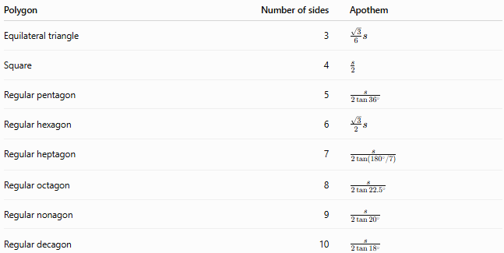
Polygon | Number of sides | Apothem
Equilateral triangle | 3 | $$\frac{\sqrt{3}}{6}s$$
Square | 4 | $$\frac{s}{2}$$
Regular pentagon | 5 | $$\frac{s}{2\tan{{36}^{∘}}}$$
Regular hexagon | 6 | $$\frac{\sqrt{3}}{2}s$$
Regular heptagon | 7 | $$\frac{s}{2tan⁡\left({180}^{∘}/7\right)}$$
Regular octagon | 8 | $$\frac{s}{2\tan{{22.5}^{∘}}}$$
Regular nonagon | 9 | $$\frac{s}{2\tan{{20}^{∘}}}$$
Regular decagon | 10 | $$\frac{s}{2\tan{{18}^{∘}}}$$

Apothem and Side Midpoint
# Source: AI Source: Provided by: [Data Path: Persons Table -> ID Column: 1, Name_En Column: Motasem Essam] -> From: [ChatGPT] on [7/25/2026]
In a regular polygon, the apothem always ends at the midpoint of a side.
For side $AB$:
$$\boxed{AM=MB}$$
and:
$$\boxed{OM⊥AB}$$
Thus $OM$is the perpendicular bisector of side $AB$.
Because the polygon is regular, the same property holds for every side.

Apothem vs. Radius
# Source: AI Source: Provided by: [Data Path: Persons Table -> ID Column: 1, Name_En Column: Motasem Essam] -> From: [ChatGPT] on [7/25/2026]
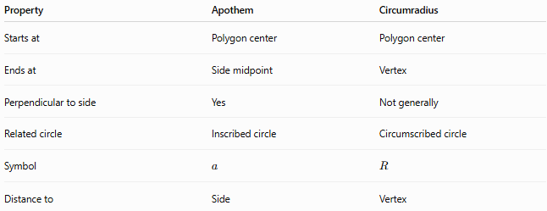
Property | Apothem | Circumradius
Starts at | Polygon center | Polygon center
Ends at | Side midpoint | Vertex
Perpendicular to side | Yes | Not generally
Related circle | Inscribed circle | Circumscribed circle
Symbol | $$a$$ | $$R$$
Distance to | Side | Vertex
For a regular polygon:
$$\boxed{a<R}$$
for every finite $n$-gon.

Apothem vs. Inradius
# Source: AI Source: Provided by: [Data Path: Persons Table -> ID Column: 1, Name_En Column: Motasem Essam] -> From: [ChatGPT] on [7/25/2026]
These are effectively the same quantity for a regular polygon:
$$\boxed{a=r}$$
The apothem emphasizes the polygon, while the inradius emphasizes the inscribed circle.

Apothem vs. Altitude
# Source: AI Source: Provided by: [Data Path: Persons Table -> ID Column: 1, Name_En Column: Motasem Essam] -> From: [ChatGPT] on [7/25/2026]
They are different concepts.
Apothem
Distance from the center of a regular polygon to one of its sides:
$$\boxed{a=\text{center-to-side distance}}$$
Altitude
Perpendicular distance from a vertex to the opposite side or its supporting line.
Therefore:
$$\boxed{\text{Apothem}≠\text{Altitude}}$$
in general.
For an equilateral triangle, however, the apothem is one-third of the altitude:
$$\boxed{a=\frac{h}{3}}$$

Special Case — Square
# Source: AI Source: Provided by: [Data Path: Persons Table -> ID Column: 1, Name_En Column: Motasem Essam] -> From: [ChatGPT] on [7/25/2026]
For a square with side length $s$:
$$\boxed{a=\frac{s}{2}}$$
The apothem is simply the distance from the center to any side.
Its circumradius is:
$$R=\frac{s\sqrt{2}}{2}$$
so:
$$a=\frac{R}{\sqrt{2}}$$

Special Case — Regular Hexagon
# Source: AI Source: Provided by: [Data Path: Persons Table -> ID Column: 1, Name_En Column: Motasem Essam] -> From: [ChatGPT] on [7/25/2026]
For a regular hexagon:
$$\boxed{a=\frac{\sqrt{3}}{2}s}$$
Its circumradius equals its side length:
$$\boxed{R=s}$$
Therefore:
$$\boxed{a=\frac{\sqrt{3}}{2}R}$$

Classification
# Source: AI Source: Provided by: [Data Path: Persons Table -> ID Column: 1, Name_En Column: Motasem Essam] -> From: [ChatGPT] on [7/25/2026]
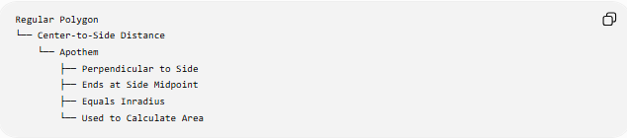
Regular Polygon
└── Center-to-Side Distance
└── Apothem
├── Perpendicular to Side
├── Ends at Side Midpoint
├── Equals Inradius
└── Used to Calculate Area

Important Properties
# Source: AI Source: Provided by: [Data Path: Persons Table -> ID Column: 1, Name_En Column: Motasem Essam] -> From: [ChatGPT] on [7/25/2026]
- The apothem exists as a standard polygon concept for regular polygons.
- It extends from the polygon's center to a side.
- It is perpendicular to that side.
- It meets the side at its midpoint.
- All apothems of the same regular polygon are equal.
- The apothem equals the radius of the polygon's inscribed circle.
- It is always shorter than the circumradius.
- It is fundamental to the regular-polygon area formula:
$$\boxed{A=\frac{1}{2}Pa}$$
- For a regular $n$-gon:
$$\boxed{a=\frac{s}{2tan⁡\left({180}^{∘}/n\right)}}$$

Applications
# Source: AI Source: Provided by: [Data Path: Persons Table -> ID Column: 1, Name_En Column: Motasem Essam] -> From: [ChatGPT] on [7/25/2026]
Apothems are used in:
- Regular polygon geometry
- Area calculations
- Inscribed circles
- Circumscribed circles
- Polygon construction
- Architectural design
- Engineering
- CAD
- Computer graphics
- Regular tiling and tessellations

Key Points
# Source: AI Source: Provided by: [Data Path: Persons Table -> ID Column: 1, Name_En Column: Motasem Essam] -> From: [ChatGPT] on [7/25/2026]
$$\boxed{\text{Apothem}=\text{center-to-side perpendicular distance}} \\ \boxed{OM⊥AB} \\ \boxed{AM=MB=\frac{s}{2}} \\ \boxed{a=\frac{s}{2tan⁡\left({180}^{∘}/n\right)}} \\ \boxed{a=Rcos⁡\left({180}^{∘}/n\right)} \\ \boxed{A=\frac{1}{2}Pa}$$
and for a regular polygon:
$$\boxed{a=r}$$
where $r$is the inradius.

Conclusion
# Source: AI Source: Provided by: [Data Path: Persons Table -> ID Column: 1, Name_En Column: Motasem Essam] -> From: [ChatGPT] on [7/25/2026]
The apothem is the perpendicular distance from the center of a regular polygon to any of its sides. It reaches the midpoint of the side and is equal to the inradius of the polygon's inscribed circle. The apothem is particularly important because it converts the area of a regular polygon into the simple formula
$$\boxed{A=\frac{1}{2}Pa}$$
making it one of the fundamental measurements associated with regular polygons.

